***Aura Gold Design Strap Watch***

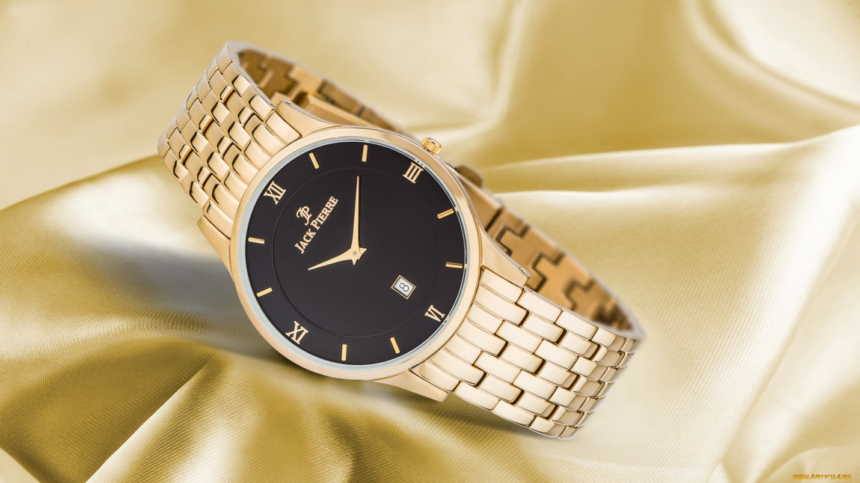

***DETAILS ABOUT THIS WATCH***

MOVEMENT: SEIKO VD53 (3 YEAR BATTERY LIFE)  
FUNCTIONS: HOURS, MINUTES, CENTRAL SECONDS, DATE, CHRONO SECONDS, MINUTES, 24 HOURS  
CASE MATERIAL: HAND FINISHED 316L STAINLESS STEEL  
CASE DIMENSIONS: 46MM X 12MM  
CRYSTAL: HARDENED MINERAL  
WATER RESISTANCE: 10 ATM  
STRAP: SOLID STAINLESS STEEL 3-LINK BRACELET WITH BUILT-IN QUICK RELEASE SPRINGBAR SYSTEM TO EASILY SWAP OUT STRAPS

***Spaces***

**CASE SIZE:**46mm

**CASE SHAPE:**Round

**CASE MATERIAL:**Stainless Steel

**CASE THICKNESS:**12mm

**CRYSTAL TYPE:**Mineral

**MOV'T TYP**

***Price:***

***Rs:5000***